Exercise 2: Implementing Dependency Injection
Dependencies
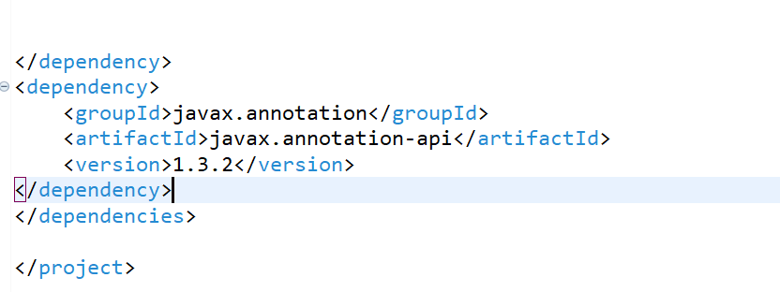
applicationContext.xml
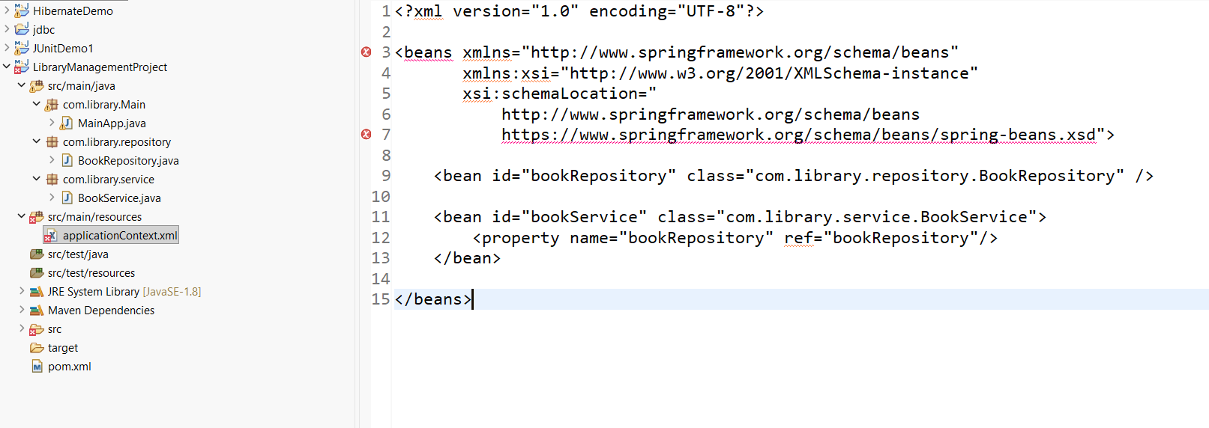
BookRepository
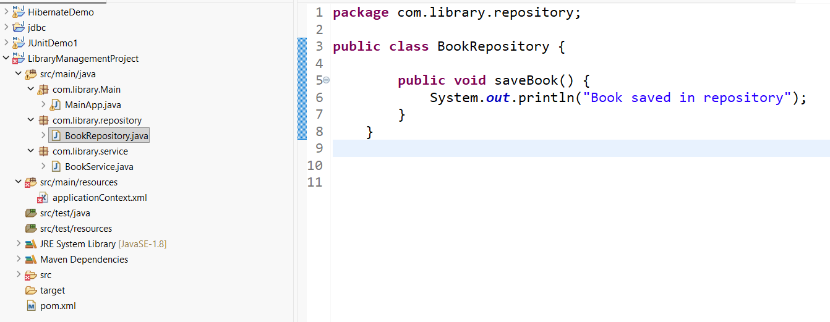
BookService
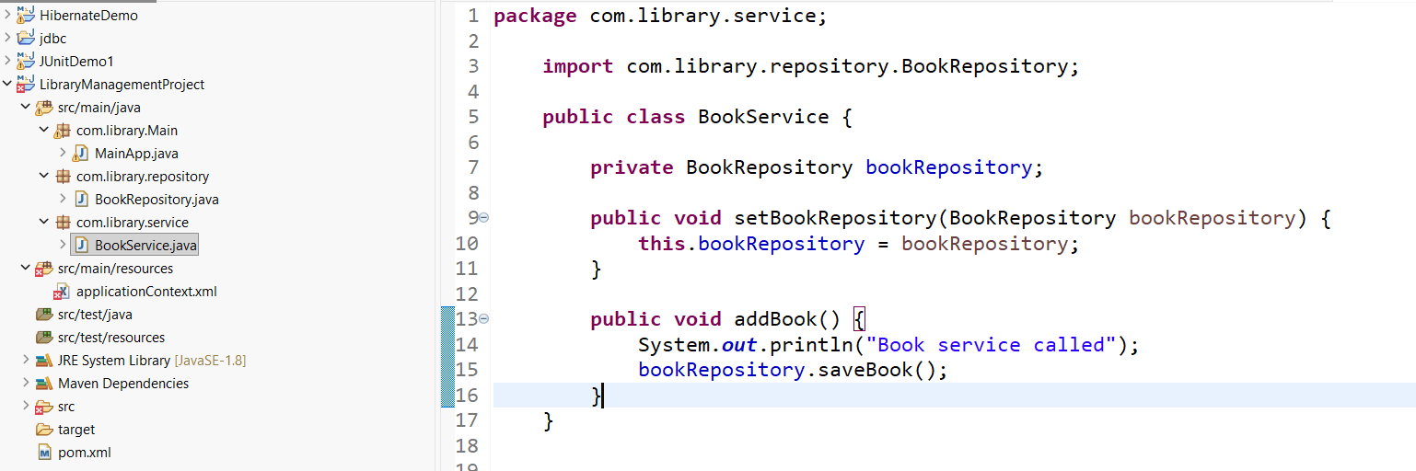

Main class
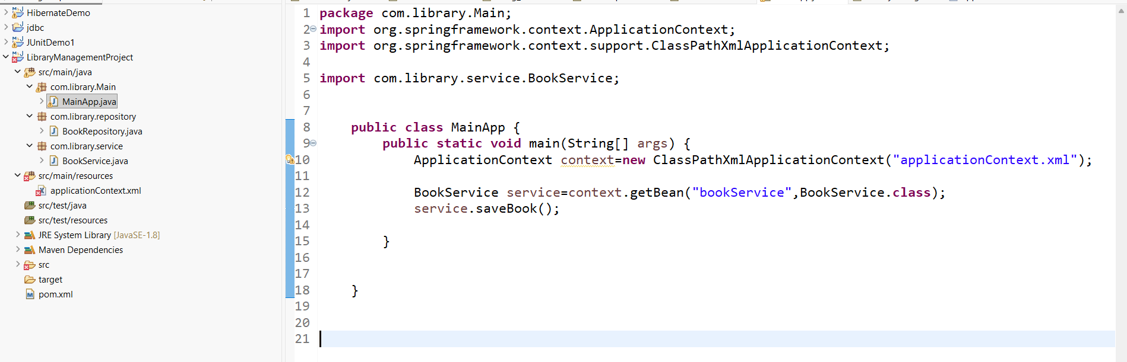
Output:
